Chill Hack Solution Documentation
Written By: Yuval Quina
I started this challenge by executing a Nmap ports and services scan:
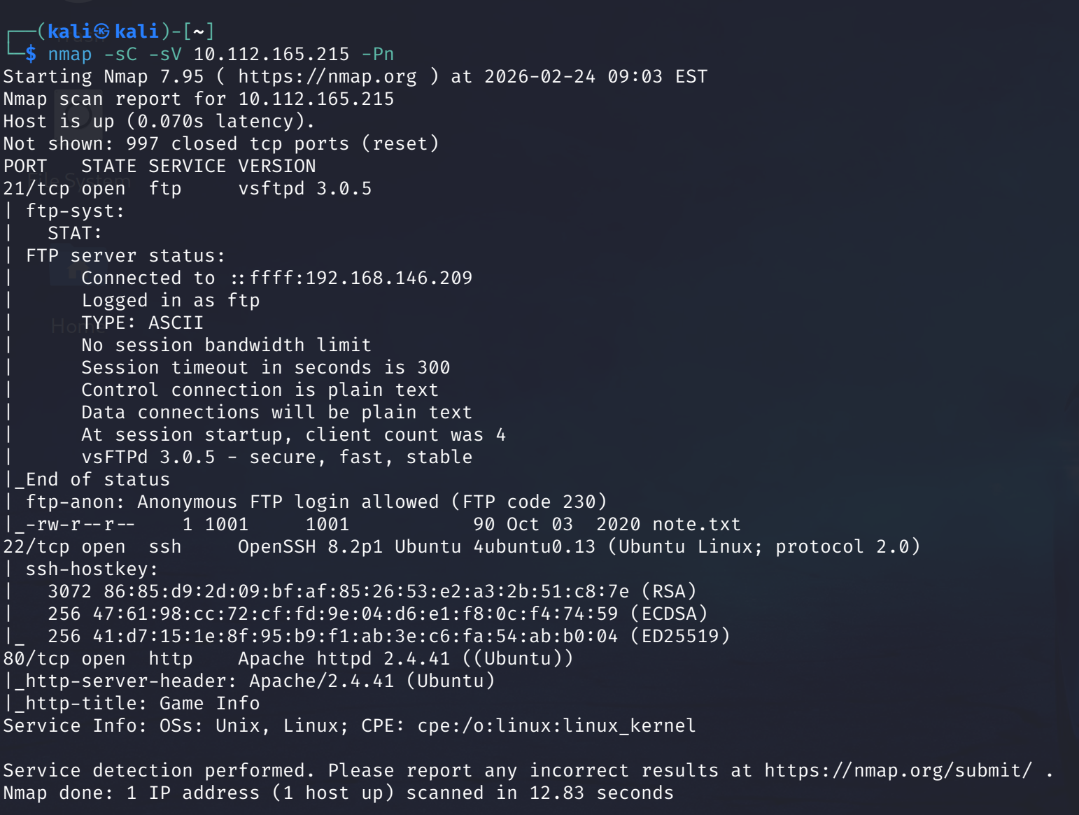
I found that it was possible to access the fts service of the target using the username “Anonymous” and that it contains a txt file named “note.txt”.
This info led me open the note.txt file using the “ftp” utility. I entered as “Anonymous” with no password and I successfully logged in:
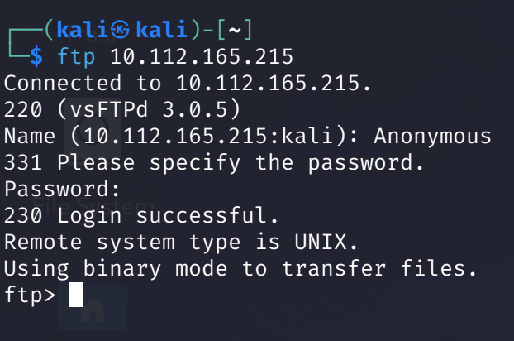
And I transferred the txt file to my machine: 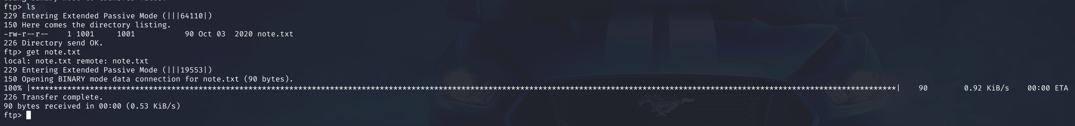
And this is its content:
I read this clue and kept it for later use.
On this point, I entered the website:

I understood that this website it themed as sport website and I started exploring it. I run a gobuster directories enumeration:
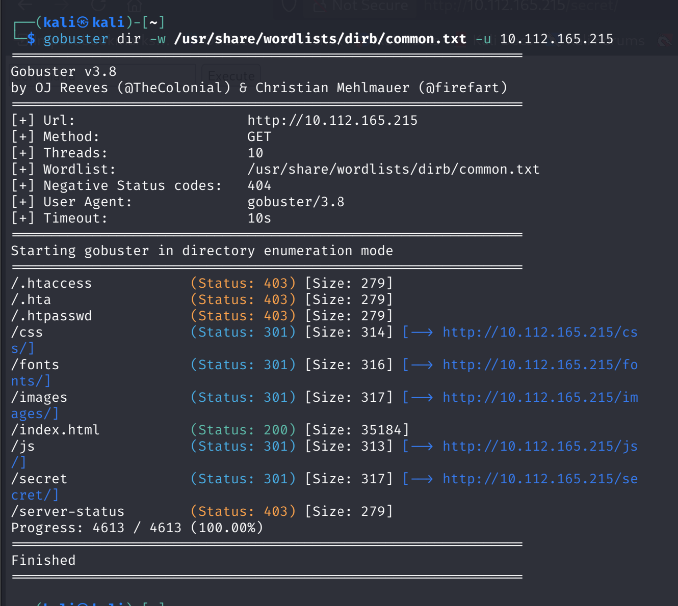
I found a suspicious directory named “/secret”, so I opened it:
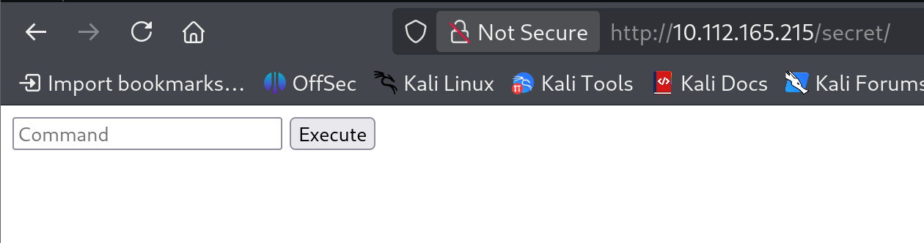
I checked this command bar with the known linux command “id”:
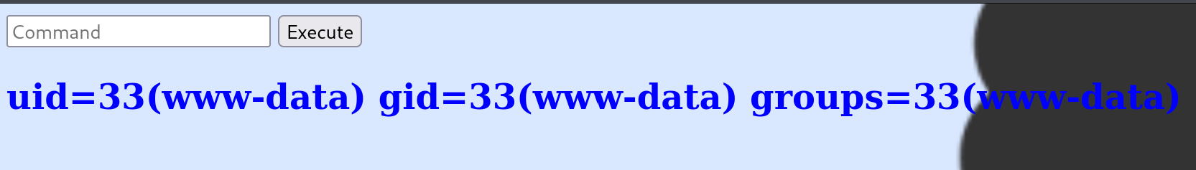
And it was found to work!
Thereafter, I thought of creating a reverse shell over the target’s machine. In order to get it, first of all, I established this netcat listener:

